**GOVERNMENT OF ANDHRA PRADESH**

**GVWV & VSWS DEPARTMENT**

**Auto Nagar, Vijayawada**

**Address certificate for Aadhar Enrolment/Update**

**User Manual**

**April 2023**

# **Service Overview**

The Government of Andhra Pradesh is providing a new service called address certificate for Aadhar Enrolment/Update for the citizens who wish to update their address in Aadhar. This will be helpful in updating the new districts in Aadhar.

The application will be raised by the Digital Assistant (DA)/Ward education and data processing secretary (WEDPS) in the secretariat and the verification and approval authority for this service is the based on the designation work flow

1. if rural is selected the final approval will be VRO and PS
2. if urban is selected the final approval will be WRS and WAS

Once the application is verified and approved, the certificate should be filled by the VRO manually for the fields mentioned below:

1. Signature/thumb impression of citizen
2. Passport size photo of citizen
3. Certifier’s (VRO) checklist
4. Signature and stamp of the certifier (VRO)

The certificate can be used as proof of address only and it is valid for 3 months from the date of issue.

**Note:** The certificate should be printed on A4 size paper and not on secured stationary.

|  |  |
| --- | --- |
| Category | Category B |
| Fee | Rs 20 |
| SLA | 7 Days |
| Documents Checklist | Aadhar card  Other documents: Rice card/Driving License/Passport/Electricity bill/Gas bill |

# **Application process in DA/WEDS login**

**Service Name** - **Address Certificate for Aadhar enrollment/Update**

**Website URL**- **https://vswsonline.ap.gov.in/#/home**

1. Enter the Website URL in the browser and log in with your credentials.

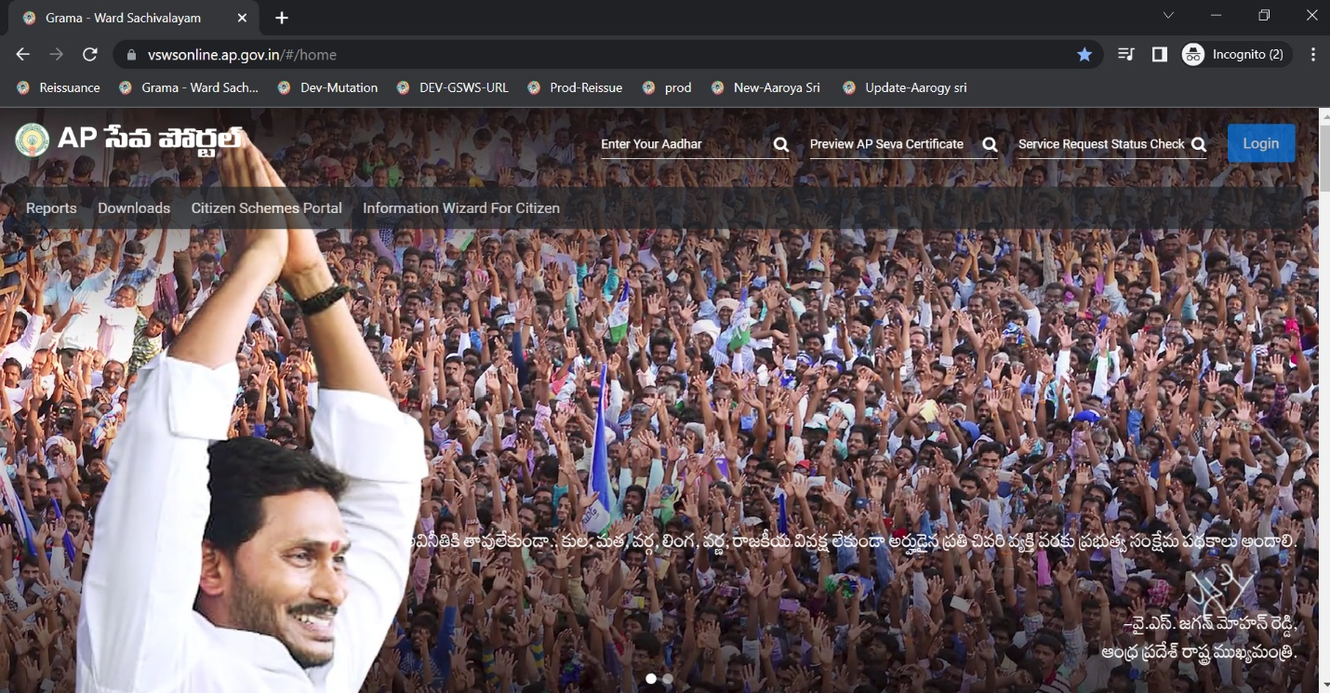

1. Click on the service name in the menu under the GSWS Services - Address Certificate for Aadhar Enrollment/Update

1. Fill in the basic details: Enter Aadhar Number → Click on prefill. If the details are not available to populate from the household database, enter all the fields manually.

1. Permanent Address will be prefilled based on the Aadhar Number given in the basic details form. If Present Address is the same as Permanent Address, then click on “Present Address is same as Permanent Address” else Enter the Address Manually.

**Note:** Postal Office and Village details will be displayed based on Pin code and need to be selected based on the Postal Office located near the Applicant’s Address.

1. Click on Continue to proceed to the Application Form.
2. Enter all the mandatory fields i.e., the purpose of certificate, Area/Locality/Sector, street/Road/lane,village/town/city,nearby Landmark to your address & Panchayat name/ward number.

**Note:** The panchayat name/ward number should be entered as per the applicant’s sachivalayam address.

g)select District,Mandal ,village/ward/secretariat

h) Select the Designation

**Note :**

**If it is Rural workflow then we will get Village Revenue Officer and Panchayat Secretary in designation dropdown**

**II) If it is Urban workflow then we will get Ward Revenue Secretary and Ward**

**Admin Secretary**

I) Upload the mandatory documents and click on the declaration checkboxes. Click on the show payment button.

j) After clicking on show payment, it will redirect to the payment gateway page and select the desired mode of payment. Charges for the service are Rs 20.

1. Click on the continue payment button and a payment receipt will be generated.

# **Approval process**

1. Enter the URL https://vswsonline.ap.gov.in/#/home & login using your credentials.

1. Once logged in the address certificate service request will be shown.

1. Select the application and the applicant details will be shown.

1. Verify all the details in the application and check all the documents uploaded. Click on the radio button for **Is** **Applicant is residing in same Village** field after the field verification is completed.

1. Select the remarks as “Recommended” or “Not recommended” and click on the declaration checkbox.

1. “Application Approved” pop-up message will display on successfully approving the application when clicked on approve button. Once approved print the certificate on A4 size paper and fill in the details required as mentioned on **page 2**.

1. “Application Rejected” pop-up message will display on successfully rejecting the application when clicked on the reject button and need to select the reject reason.

**Sample Rural Certificate:**

Sample certificate for Urban:

